Restricting activity access

In the settings of each activity there is a Restrict Access section. To get to this, click 'Edit' alongside the activity you want to restrict and then choose 'Edit Settings', or add a new activity, which will bring you to the settings page.

In the 'Restrict Access' section of the activity settings page, click the 'Add restriction' button. A choice of conditions appears:

[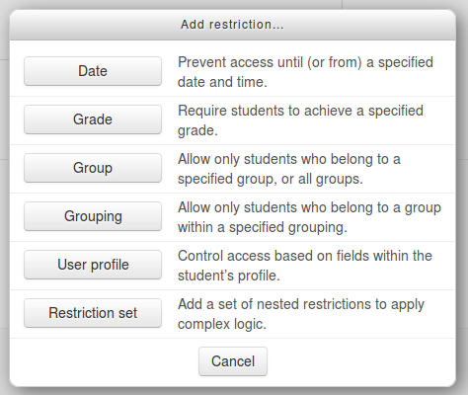](https://docs.moodle.org/31/en/File:add_restriction_popup.png)

Restriction can be based upon [Activity completion](https://docs.moodle.org/31/en/Activity_completion), date, grade, the group or grouping the students are in or even user profile fields. The 'Restriction set' button also allows for more complex criteria requiring nested conditions.

Activity completion

See [Activity completion](https://docs.moodle.org/31/en/Activity_completion). Note that this button only appears if you have Activity completion enabled by the administrator in your site, and it is enabled in your course in *Course administration > Edit settings > Completion tracking*.

Date

Access can be restricted from or until a certain date and time.

[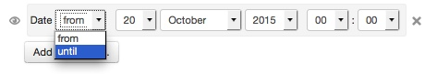](https://docs.moodle.org/31/en/File:availabilityrestrictionbydatefromuntil_m30.png)

Grade

You can specify a condition on any grade in the course: the full course grade, the grade for any activity, or a custom grade that you create manually. You can enter either a minimum value (at least percentage), a maximum value (less than percentage), both, or neither. The activity will only appear if the student has a value for the specified grade, and if it falls within any specified number range. You can add more than one grade condition. All conditions must be met in order for the activity to appear.

* The range numbers can be fractional (with up to five decimal places) if necessary.
* Be careful with the maximum value; if the maximum is 7, a student who scores exactly 7 will not see the activity. You could set it to 7.01 if you really wanted to include 7.
* If creating several different activities that appear according to grade ranges, use the same number for the maximum of one activity, and the minimum of the next. For example, you might create one activity with a maximum of 7 and another with a minimum of 7. The first would appear to everyone scoring between 0 and 6.99999, and the second would appear to everyone scoring 7.00000 to 10. This guarantees that everyone with a grade will see one or other.To remove a grade condition, set the assessment name to 'none' and remove the range number values
* If you want to use a condition for students with blank grades then you can add a grade restriction and select the activity you want to use as a restriction. Do not select a checkbox for either the greater than or less than criteria. This will require the student to have a grade. This means students with blank grades do not meet that criterion.

Group and groupings

If groups or groupings are used in the course, it is possible to restrict the activity to a certain group or grouping. If they are turned off for this course and not available, these options will not be present for use as an restriction.

[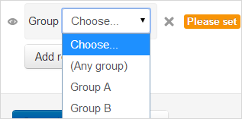](https://docs.moodle.org/31/en/File:grouprestrict.png)

**NOTE**: This button only appears if you have groups **enabled** in your course.

User profile

Access can be restricted using one of the following user fields:

* Address - This is the value in the 'address' column
* AIM ID - This is the value in the 'aim' column
* City/town - This is the value in the 'city' column
* Country - This is the two letter country code, NOT the name of the country.
* Department - This is the value in the 'department' column
* Email Address - This is the value in the 'email' column
* First name - This is the value in the 'firstname' column
* ICQ number - This is the value in the 'icq' column
* ID number - This is the value in the 'idnumber' column
* Institution - This is the value in the 'institution' column
* Mobile phone - This is the value in the 'phone2' column
* MSN ID - This is the value in the 'msn' column
* Phone - This is the value in the 'phone1' column
* Skype ID - This is the value in the 'skype' column
* Surname - This is the value in the 'lastname' column
* Web page - This is the value in the 'url' column
* Yahoo ID - This is the value in the 'yahoo' column

Restriction set

This allows you to add a set of complex restrictions to apply complex logic. See [Using restrict access](https://docs.moodle.org/31/en/Using_restrict_access) for an example.